**Superme (RTS game)**

**A PROJECT REPORT**

***Submitted by***

**Anish Acharya(1418BECE30012)**

***In fulfillment for the award of the degree***

***of***

**BACHELOR OF ENGINEERING**

***in***

CE(1ST Shift)

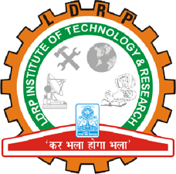

**LDRP Institute of Technology and Research, Gandhinagar**

**Kadi Sarva Vishwavidyalaya**

**April/May, 2018**

***LDRP Institute of Technology and Research***

***Gandhinagar***

**CE-IT Department**

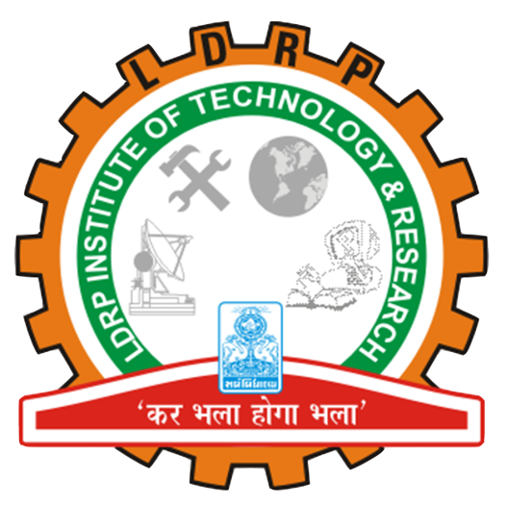

CERTIFICATE

This is to certify that the Project Work entitled **“Superme (RTS game)”** has been carried out by **Anish Acharya (1418BECE30012)** under my guidance in fulfilment of the degree of Bachelor of Engineering in Computer Engineering (8th Semester) of Kadi Sarva Vishwavidyalaya during the academic year 2017-18.

**Krutika Vyas**  Dr.Hiren B. Patel

**Internal Guide** **Head of the Department**

**LDRP ITR LDRP ITR**